**DAILY ONLINE ACTIVITIES SUMMARY**

|  |  |  |  |  |  |  |  |  |
| --- | --- | --- | --- | --- | --- | --- | --- | --- |
| **Date:** | **29-5-2020** | | | | | **Name:** | **Likhitha.M** | |
| **Sem & Sec** | **6th sem ‘A’** | | | | | **USN:** | **4al17cs046** | |
| **Online Test Summary** | | | | | | | | |
| **Subject** | | **Operations research** | | | | | | |
| **Max. Marks** | | **30** | | **Score** | | | **30** | |
| **Certification Course Summary** | | | | | | | | |
| **Course** | **Cloud Foundations** | | | | | | | |
| **Certificate Provider** | | | **Great learning** | | **Duration** | | | **3 days** |
| **Coding Challenges** | | | | | | | | |
| **Problem Statement:**  **1.**Python program to calculate the number of lowercase and uppercase letters in a string  2.We are given 3 strings: str1, str2, and str3. Str3 is said to be a shuffle of str1 and str2 if it can be formed by interleaving the characters of str1 and str2 in a way that maintains the left to right ordering of the characters from each string. For example, given str1="abc" and str2="def", str3="dabecf" is a valid shuffle since it preserves the character ordering of the two strings. So, given these 3 strings write a function that detects whether str3 is a valid shuffle of str1 and str2. 3.Write a c program to solve a system of linear congruences by applying the Chinese Remainder Theorem. 4.We are given 3 strings: str1, str2, and str3. Str3 is said to be a shuffle of str1 and str2 if it can be formed by interleaving the characters of str1 and str2 in a way that maintains the left to right ordering of the characters from each string. For example, given str1="abc" and str2="def", str3="dabecf" is a valid shuffle since it preserves the character ordering of the two strings. So, given these 3 strings write a function that detects whether str3 is a valid shuffle of str1 and str2. 5.Write a c progam to solve a system of linear congruences by applying the Chinese Remainder Theorem. #include <stdio.h> | | | | | | | | |
| **Status: completed** | | | | | | | | |
| **Uploaded the report in Github** | | | | | **yes** | | | |
| **If yes Repository name** | | | | | **https://github.com/likhithaMantaral/Daily-status** | | | |
| **Uploaded the report in slack** | | | | | **yes** | | | |

Online test Details:

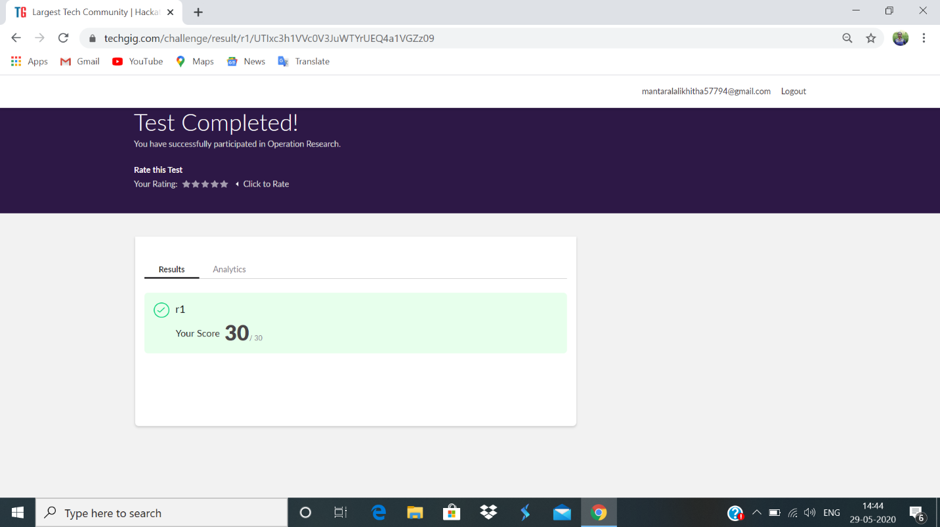

Certification Course Details:

**Classical enterprise, why cloud and evolution of cloud.**

Learnt about some typical IT landscape of a typical and classical enterprise that is:

1.portal

2.search

3.content management

4.middleware/ESB and many more.

Python/java/c++ runs nice on the cloud.

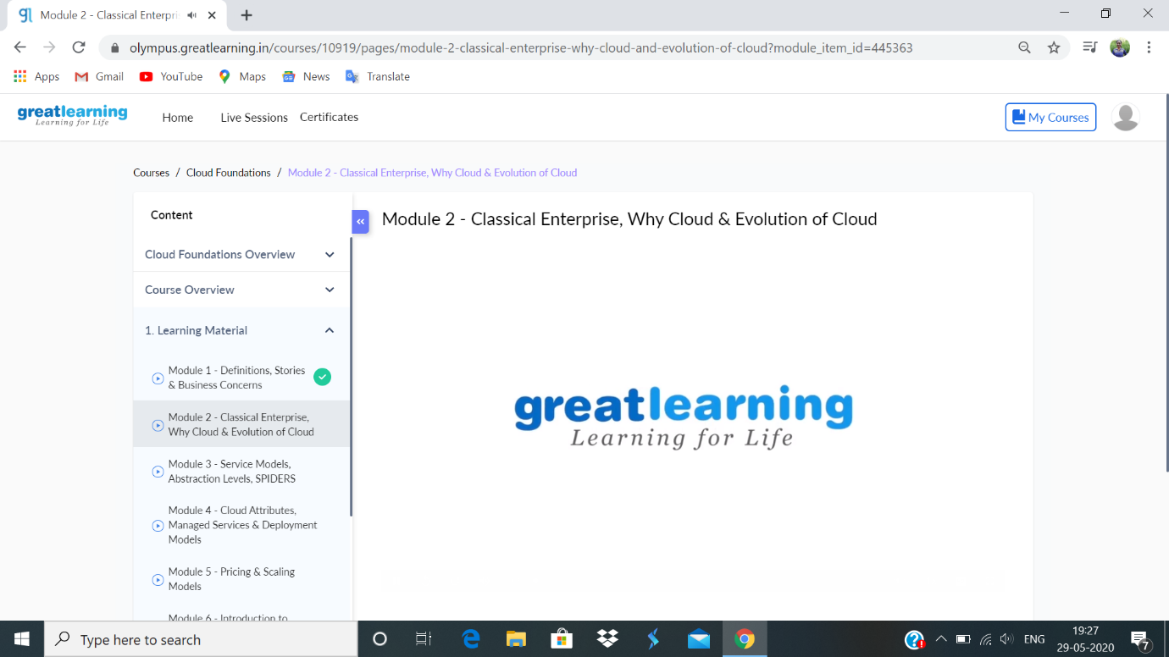

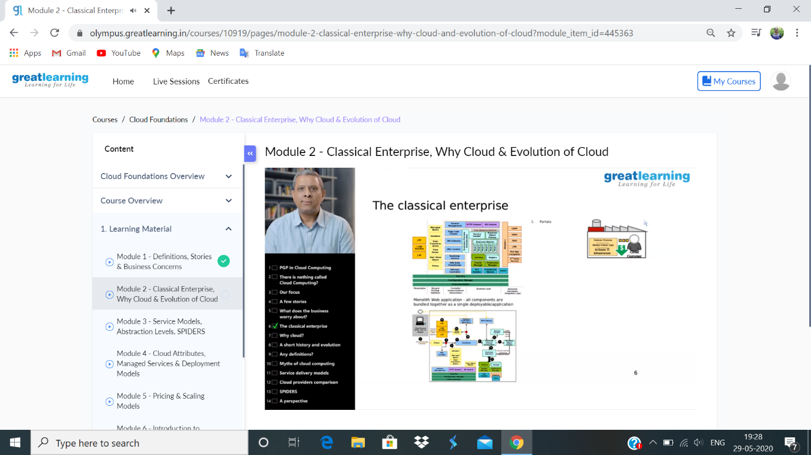

**Coding challenge:**

**1.** 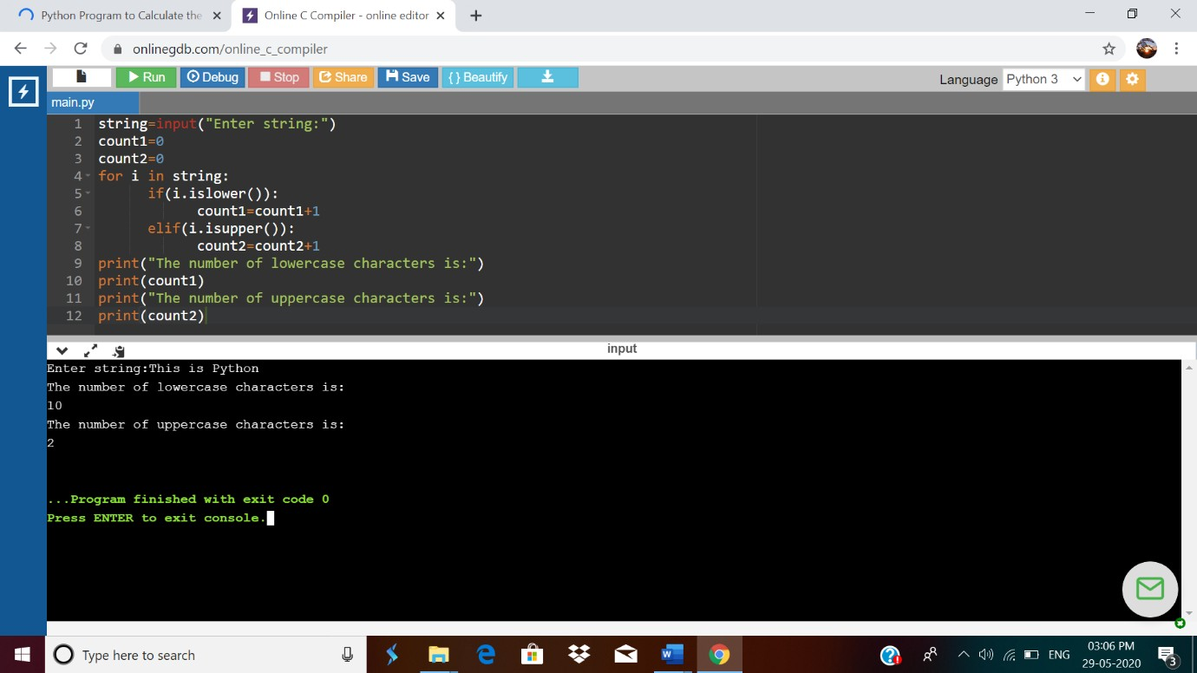

**2.**

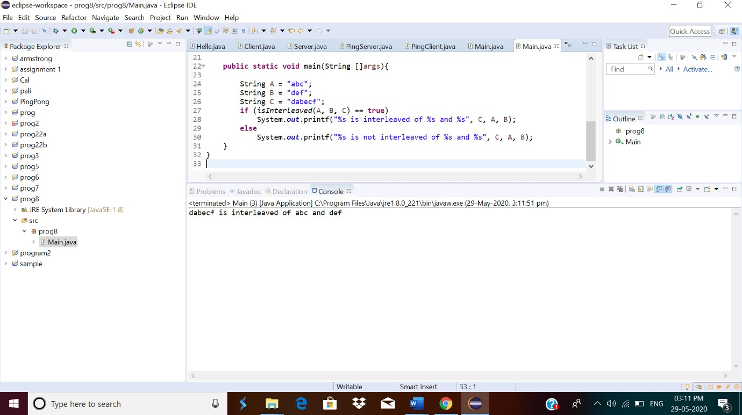

3.



4.

5.

